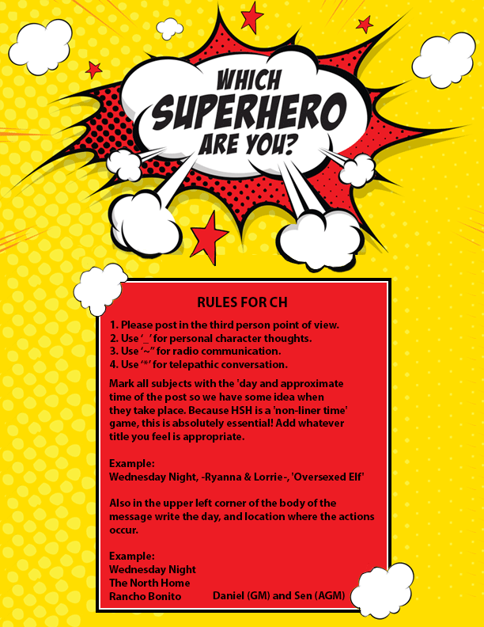

YN  ATTRIBUTES  AGE: 14  EYE COLOR: Blue  HAIR COLOR: Brown  DISTINGUISHING MARKS:  A half-moon shaped burn mark on her left abdomen, from the time her father burned her with a fireplace poker  RACE: Human/werewolf  GENDER: Female  DOMINANT HAND: left  HEIGHT: 4’ 9” WEIGHT: 90 pounds  INTERESTING FACTS  LIKES: Mila is a bookworm, she loves to read and study. Her favorite subject is science, particularly animals.  DISLIKES: Mila is a gentle soul, she hates bullies and people who yell. She also doesn’t like math.  SKILLS: Mila is good at memorizing animal facts, she is quiet and caring and can easily calm scared animals, or people, for that matter.  LANGUAGES: English | Mila Jo Henry  Whisperer  SUPER POWERS  Include Name of Power * Range * Area of Effect * Power Description  *Animal Healing*  Mila has always been super sensitive to animals who are in trouble or injured. She remembers a time when she was very little where her dad hit a cat with his car, and it felt like someone was tearing her apart…because she couldn’t do anything for the animal who was suffering. After she becomes a werewolf, Mila realizes very quickly that she can help animals, by healing small injuries and illness. With time, she will be able to heal even more.  *Werewolf*  Mila is bitten by Benjamin Stone, and becomes a werewolf. She has enhanced speed, strength and healing, as well as improved senses. She has a Crinos form, and will shift during the full moon. With this comes increased hunger and aggression.  APPEARANCE  Mila is still growing, and on the cusp of hitting puberty. She’s tall for her age, and skinny, but will fill out quickly. She has long, dark brown hair that she puts up, usually in a bun. Her most striking feature is her bright blue eyes, hidden behind big-rimmed glasses. Her clothing is mostly jeans and hand-me-down shirts.  PERSONALITY  Mila is a sweet and caring little girl, often seen as timid upon first meeting. She knows a lot, and I mean a lot about animals, so she can be over-talkative when it comes to that. She talks even more when she’s trying to make friends, which sometimes turns them off. Sometimes she is brave, but the minute someone starts yelling at her, she tends to retreat into the background.  HISTORY  Mila Jo Henry is the only daughter of Kyla and Parker Henry. They never really had a lot of money, and Parker was physically abusive to his wife and daughter. When Kyla was killed in the invasion, Parker went completely crazy. It wasn’t long after that he lost his factory job, and the family of two began surviving on Parker’s unemployment checks. Really, he spent most of their money on alcohol, and his little girl knew what it was like to be left alone for hours, or overnight.  One thing Mila really loved was animals. Even from a young age she had an affinity for them, dogs and cats seeming drawn to her. The most vicious neighborhood dog would roll over and let little Mila scratch it’s belly. It was hard, dealing with losing her mother, as well as her father’s nasty temper and physical abuse. So, Mila turned to books, mostly about animals. She read everything she could get her hands on, and became considered somewhat of a nerd, and a loner.  At her old school, the staff had begun to ask questions about bruises that Mila had, or about the fact that she sometimes didn’t make it into school. So, Parker packed up his daughter about a month ago and moved to Rancho Bonito. They live in a one-bedroom apartment in a bad part of town. Mila really hasn’t made any friends yet…and she wonders if anyone will ever save her from a life with her dad.

