Character Bio for Betty Sue Taylor aka Scarlett Tutera(Actor Name) aka The CopyCrusader(Superhero name)
Family : Bruce and Jenny Taylor.
Sister: Mary Anne North
Brother: Bruce Jr.
Age: 21 Birthday Feb. 15th
Eye Color: Beautiful Blue that matches her car.
Hair Color: Flowing Golden Locks
Distinguishing Marks: Her astonishing beauty
Race: Human
Gender: FEMALE
Dominant Hand: Ambidextrous
Height: 6’ 1” of Nordic Bombshell
Weight: 140 lbs of succulent female flesh
Appearance:
Scarlett looks like a runway model. She is astonishingly beautiful. Her teeth are so white you can almost see the glint of supernatural stars. Scarlett dresses in only the latest fashion. She makes certain that every part of her hair, skin, and nails are perfect. Her walk is that of a runway diva and her hair toss a thing of supernatural beauty. Her manners are impeccable…she could put Emily Post to shame.
Bio:
Betty Sue always wanted to be an actress. As a young girl she decided that actresses had it all; glitz, glamour, joie de vivre. They were all amazingly beautiful and perfect; exactly as she wanted to be. Unfortunately, Betty Sue was not a beautiful child. She wasn’t ugly…just not the stuff of male dreams. She was awkward and uncomfortable around children her own age. As she grew up, she realized that she was never going to be what she wanted. When she heard of the super’s existence she decided that only they could help her. She researched every day for hours. What she discovered was not what she expected. It was the end of her life. She and her friend Neri went to a party hosted by some friends and they turned out to be alien entities called the Vinyari. Drugged and broken, Betty Sue had Scarlett inserted into her body. In the morning, Scarlett convinced Betty Sue that it was in her best interests to become a host. She would allow the being to share her body in exchange for beauty and the ability to Copy everything she saw somebody doing. If someone is cooking; she can copy it, if someone is fighting, she can copy it. She is now Scarlett! She has decided that she has to develop some real world abilities in acting and music. She decides to attend Los Positas College in California because they teach acting and they are near the Fighter Chicks! Her dream is to become the new chick. She has seen the series FC and has integrated the moves into her psyche so that she can be all that she can be!
Powers:
Supernatural Beauty---she can tone it down for normal day to day life…but who wants to do that!
Copy---anything she sees someone do on tv she can replicate. Now, this does not include supernatural powers…but if she watches a cooking show then she can cook what they cooked. If she watches a wedding show then she could find a clothing store and take her bride to pick out a dress. If she watches a martial artist then she can fight like they do. None of her abilities are permanent; they eventually fade unless she keeps on practicing them. She can also replicate someones POWERS. So if she touches the individual, she will be able to use their powers as her own. She can gain skills by touch as well.
Pheromones: A low level power, Betty Sue can slightly manipulate the emotions of those around her. It’s more along the lines of a suggestion though and can be ignored completely by anyone.
Regeneration: High levels of Regeneration keep the Betty Sue and Scarlett alive
Skills:
Computer Aptitude: Betty Sue never really realized how good she is on a computer. She uses one constantly and has always considered it part of her world.
Driving: Betty Sue is a kick-ass driver. She loves cars and has always driven around when she is stressed. Her daddy is a mechanic and taught her about old cars. Betty Sue and her dad built her baby “Pedal” during her junior year of high school out of a friends old beat up original.

Her baby “Pedal”:

1965 Shelby Cobra CSX 4000 Series

2dr Roadster average value of around 80,000 up to 1,000,000
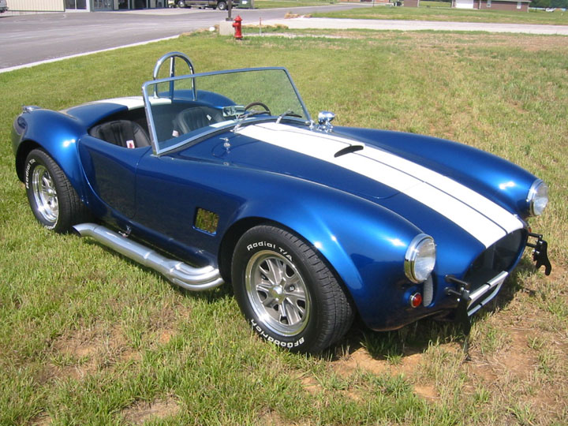
At Start of CH
Betty Sue is a new actress on the tv series, the Fighter Chicks. As a new actress, she has much to prove.

