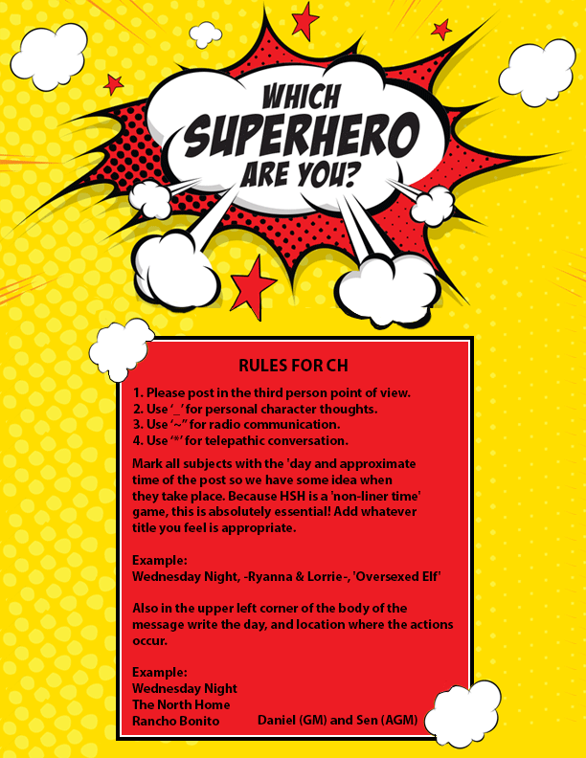

YN  ATTRIBUTES  AGE: _____18_____________  EYE COLOR: ___Hazel_______  HAIR COLOR: __Brown__  DISTINGUISHING MARKS:  Carsen has a scar running from the underside of her right wrist to her elbow.  RACE: _____Human_________  GENDER: ____Female_________  DOMINANT HAND: __right____  HEIGHT: __5’8” WEIGHT:125 lbs  INTERESTING FACTS  LIKES: Spearmint gum, folk/indie music (and pop too, no matter how hard she tries), Proving people wrong who underestimate her  DISLIKES: People who underestimate her, being controlled or hovered over, tight spaces, being vulnerable physically,the way she feels after doubling herself (weak, dizzy, with a headache)  SKILLS: Carsen has a lot of stamina and is physically fit…but her replication power does take a tole on her. She also reads very quickly, a biproduct of remembering things so well. She is a sponge when it comes to information.  LANGUAGES: English, French and American Sign Language | Carsen Rae WebEr  ________________Splitwit________________  SUPER POWERS  Include Name of Power * Range * Area of Effect * Power Description  Eidetic Memory * _________________ * _______ * ______________  Carsen has always had an exceptional memory, one that amazed both her parents and her teachers. When she hit puberty, however, it became clear that this was not only just a kid with a great mental ability. She can remember things easier, and recall information to near perfection.  Adopted Muscle Memory* _________________ * _______ * ______________  While Carsen’s memory had always been great, she soon realized that her abilities went beyond just remembering information. She figured it out after watching another girl at school (one in much better shape than her, at the time) climb a rope in PE…in record time. Carsen tried it and blew her out of the water. From that point on, she realized that as long as she watched someone do something physically, she could replicate it. It comes in handy during hand-to-hand combat, or when dealing with a particularly difficult enemy.  Replication * _________________ * _______ * ______________  Have you ever wanted to be in two places at once? The first time this happened it nearly gave Carsen a heart attack. At first, she could only replicate herself once, and her double could only mirror Carsen’s own actions before it vanished seconds later. But, the more she trains, the better Carsen gets at this particular ability. Now she can split herself in three, and complete some tasks with her body doubles before she loses control.  APPEARANCE  Carsen is a teen with a wide smile and an infectious laugh. She is tall, and while she used to be slightly overweight in her early teens, she has both slimmed down and muscled up in recent years. Looking at her, you might not see it, but she is very physically fit. She likes fashion, without really following the trends. Carsen wears a variety of different things, depending on her mood. She wears makeup, and spends time on her hair…but even when she doesn’t, her high cheekbones and big, warm eyes are inviting. Carsen is beautiful, but doesn’t really know it.__ ___________________________________________________________________  PERSONALITY  Carsen was the picture of an All-American girl before the invasion. While her powers made her different, she didn’t let the presence of them change who she was raised to be. Despite being popular, Carsen wasn’t a bully. She was generally kind to all, but also stood up for the little guy and couldn’t stand to see anyone else being put down. Her eidetic memory made her incredibly smart, which sometimes alienated her a little. It was hard to run with any particular crowd, given her differences. Athletic, smart, kind, and to others, beautiful. But secretly Carsen doubts that people really do like her for who she is, and not what she can do. She tends to get impatient, both with herself and with others. She is the type of girl to want results RIGHT NOW. Carsen also tends to run into trouble, without properly thinking it through…and while she is trying to curb that urge, it has gotten her into quite a few bad spots.  HISTORY  Carsen Rae Weber was born on May 1, 1988, to parents Will and Donna Weber. The couple had been trying for about four years to have a child, and were thrilled with little Carsen. It seemed like she did everything early, walking, talking, climbing on everything. By the age of four Carsen was reading, and she also had a little sister. The couple named their second daughter, and last child, Jayma Marie. From the moment Carsen laid eyes on the tiny baby, she loved her. There was not a big sister in the world that was more protective or adoring than Carsen.  By the time Carsen reached the second grade, her teachers informed her parents that she qualified for the gifted program. They said that for a young child, Carsen’s memory was incredible. She was reading at a college level by that point, and could understand and maintain the information she read. Will and Donna put their eldest in the special classes, but when she started to be picked on for it, they pulled her out. From then on, Carsen was one of the smartest in her class. Once Jayma started school she was just average, which started some contention between the sisters. It wasn’t that Jay wasn’t smart, it was that Carsen’s memory made her smarter.  It wasn’t until Carsen was a freshman that she realized that her memory wasn’t the only thing different about her. Another female student was bragging in gym class that no one could beat her speed record in the rope climb. All of the other students stood and watched, basically bored, as the teen did her thing. When the coach asked for a volunteer to go next, Carsen’s hand shot up. She couldn’t explain why she felt the urge to climb the rope; she had never done it before. But the moment the coach blew the whistle, Carsen managed to climb up the rope as though she could do it in her sleep. It was baffling to her, but as the school year continued, the teen figured it out. Anything that she watched someone else do, she could replicate. Carsen ran track, and after watching videos of Olympic pole vaulters, she set the school record. Of course, Carsen had heard about people with extraordinary abilities…and she didn’t want to be a part of that crowd. So, she downplayed her physical ability, not always working to her full potential, just to avoid someone noticing.  Carsen’s cover was blown during her junior year. She was walking home from school, and a car almost hit her. The stress of that moment caused her body to, for lack of a better term, double. The lady driving the car thought she had nearly hit twins crossing the street…and was confused to find only one girl when she got to Carsen. After she got home, she was able to replicate herself in the mirror…only for a few seconds at a time. The body double would do exactly what she was doing. Carsen thought it was a cool power to have, and she became more interested in pursuing it. She would practice for hours, alone in her parent’s basement…telling the family she was studying. Jayma, who was 11 at the time, became suspicious, and managed to witness the first time Carsen ever split into three. Of course, she told their parents. Will and Donna were at a loss as to what to do with their daughter and her powers. As a family they were told to keep it quiet, but Jayma, ever the prankster, let it slip to some bullies at school that her big sister was a super hero. Carsen did go and scare the bullies a little, but it also drew the attention of another powered teen. The summer before her senior year, Carsen was approached by Hunter Sutherland, a boy with visions who was working with a small group of supers. She generally liked them, and felt like she fit in. Her mom, on the other hand, thought it was dangerous to be hanging out with others like her. She thought Carsen would get hurt, or worse, killed. Still, Carsen defied her mother and hung out with them anyway…and thing were good. More than good. Until the Invasion happened.  There was chaos, and the supers that Carsen ran with tried their best to help out. It seemed like they were fighting a losing battle. Carsen’s dad, Will, was killed in the first few weeks of fighting. It took a toll on Donna, and she wanted to keep both Carsen and Jayma inside, to keep them safe. Carsen didn’t want to defy her mother’s wishes, but she was filled with grief and the need to help fight. Finally, months in, when the fighting was the heaviest, Donna gave Carsen an ultimatum. Either quit fighting and stay home, or don’t come back. Carsen left with a few changes of clothes in a backpack…promising her mother and sister she would come home. But when the invasion ended and she returned, Jayma was gone. Her mother said the 14-year-old had disappeared one night. She had left a note, that said she wanted to help like Carsen did. Jayma never returned.  In order to help Donna deal with her grief, she and Carsen moved to Rancho Bonito after the invasion ended. School has started back up, and it has been hard for Carsen to finish out her junior year in a new school…realizing that everyone has lost so much. She doesn’t use her powers, at least, not on purpose. While she cannot turn off her memory, she hasn’t replicated herself since the invasion ended. She doesn’t flaunt her physical abilities, either. Her mother is frazzled enough as it is.

